Task on cloudfront & route 53

1.Configure VPC peering in cross regions..

for this task I have configured two vpc’s in cross regions.
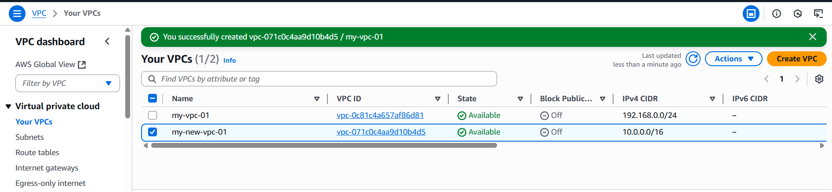
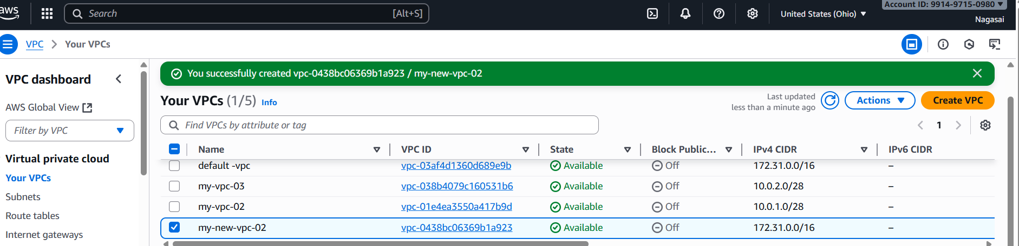
For peering connection click on peering connection in one region and accept in another region.
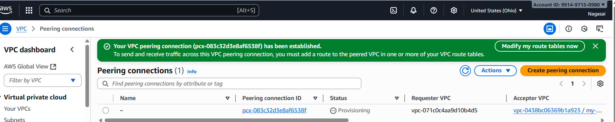
2.Purchase one domain from GoDaddy.
Go to go daddy
Search for domain find the domain with your estimated price
Select the time period youwant it for
Add cart -- checkout – payment
Domain has been purchased
You will get the confirmation mail after buying

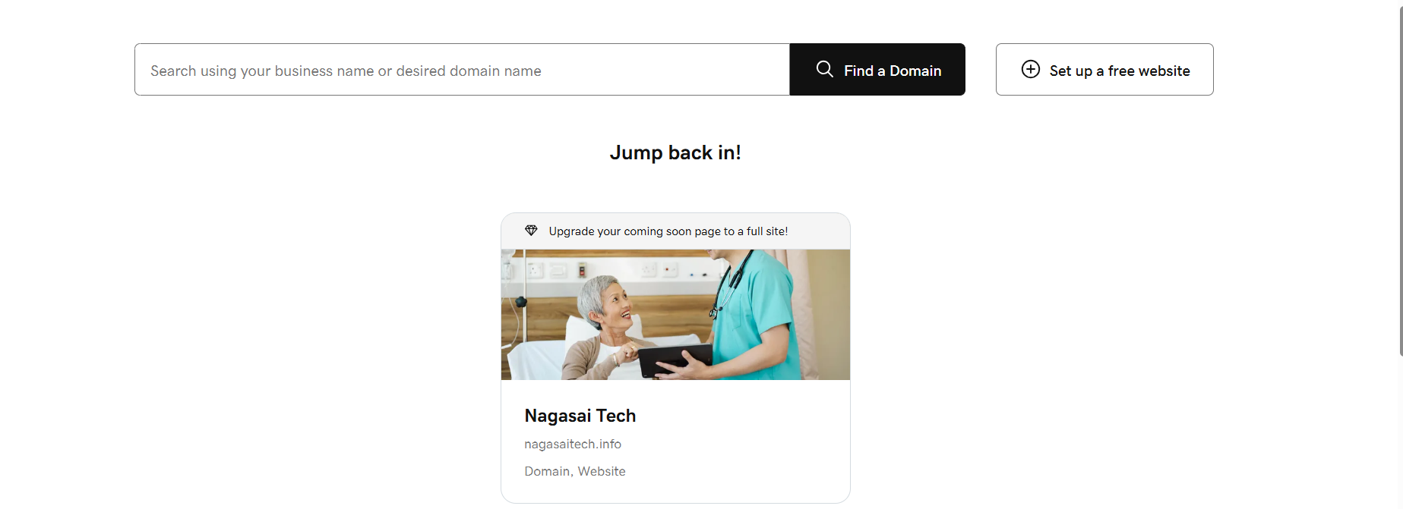

3.Deploy static website in S3.
Go to the aws console.
then search bar in s3.
Then create bucket.
Go to the permissons then create a 2 files .html files.
Then upload the files.then gave a prmsn to public
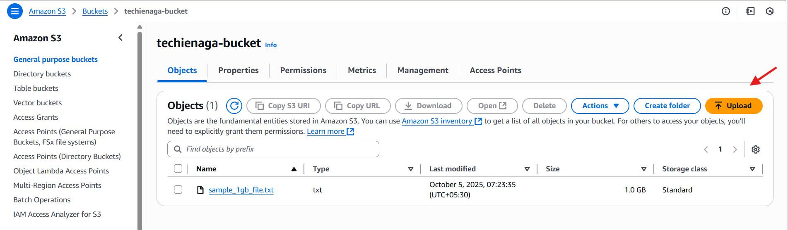
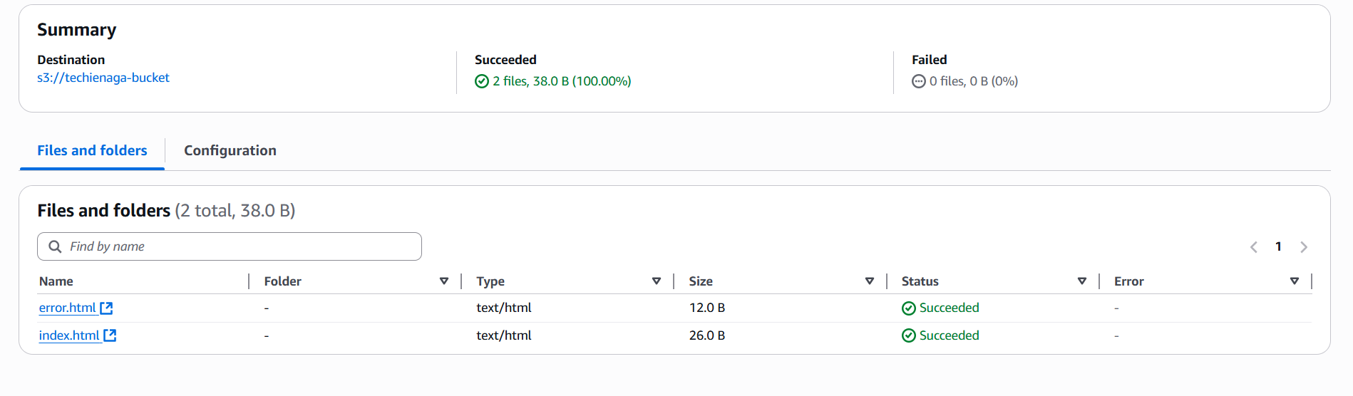
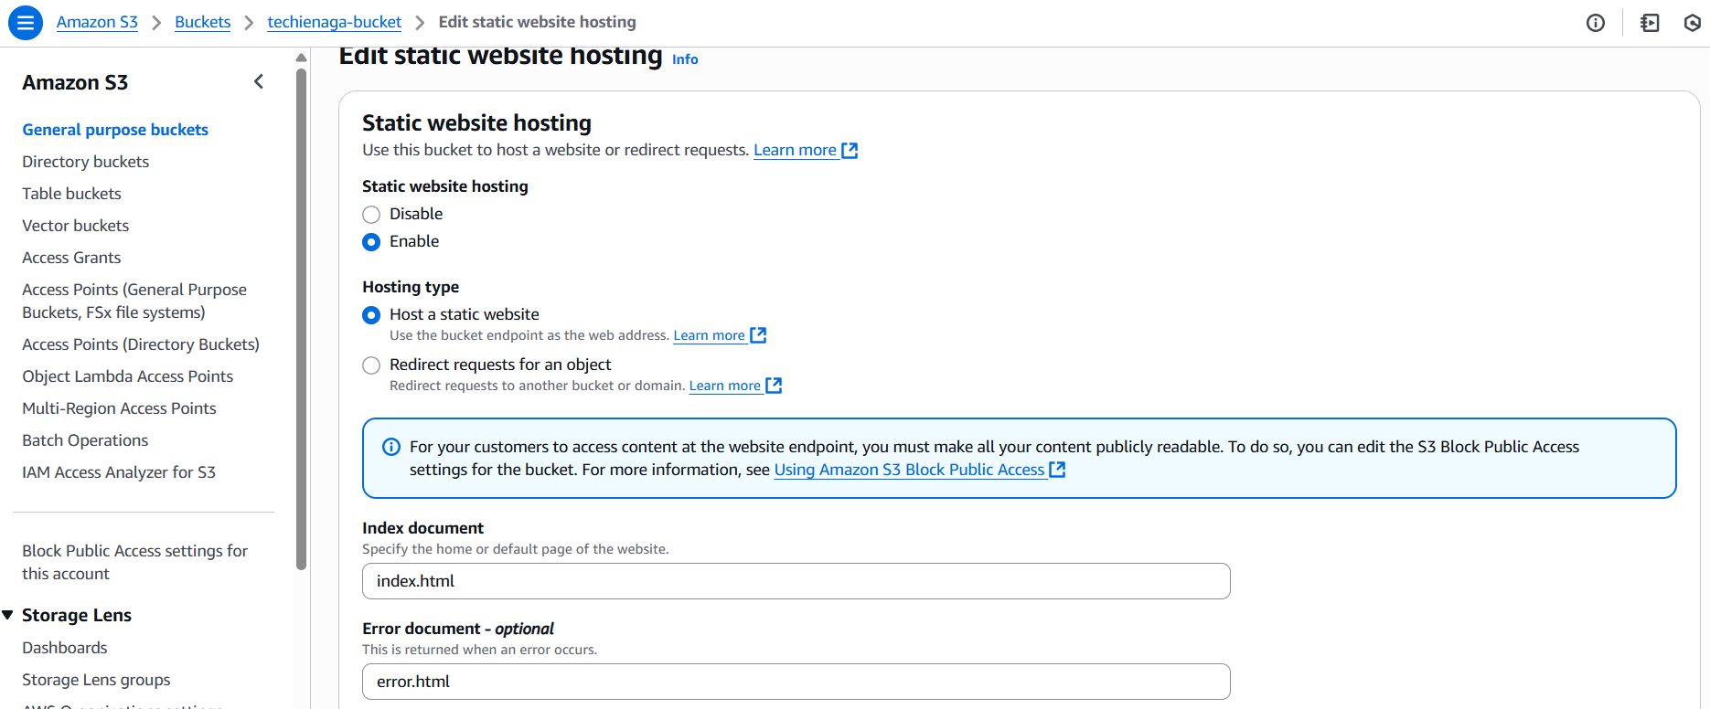
Copy the link generated and paste it in the browser to check
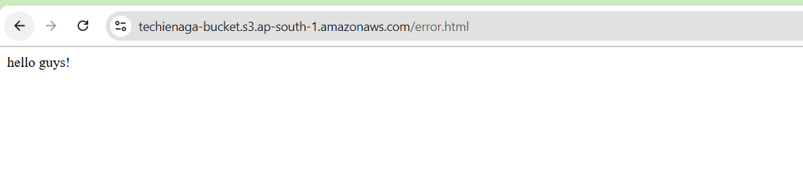
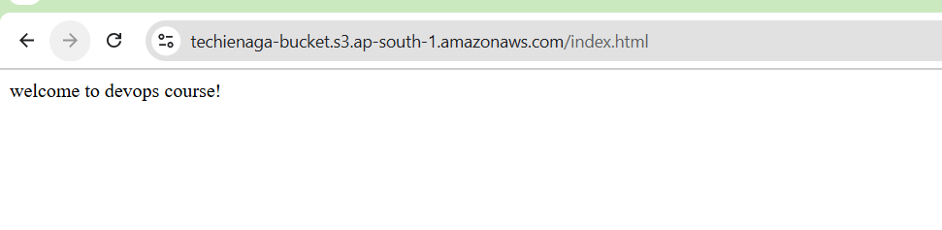

4.Create a CDN and attach one SSL certificate.
Go to the certificate in aws console
Provide the domain name that you purchased : nagasaitech.info
Then click on request
Wait for its validation it might take some time
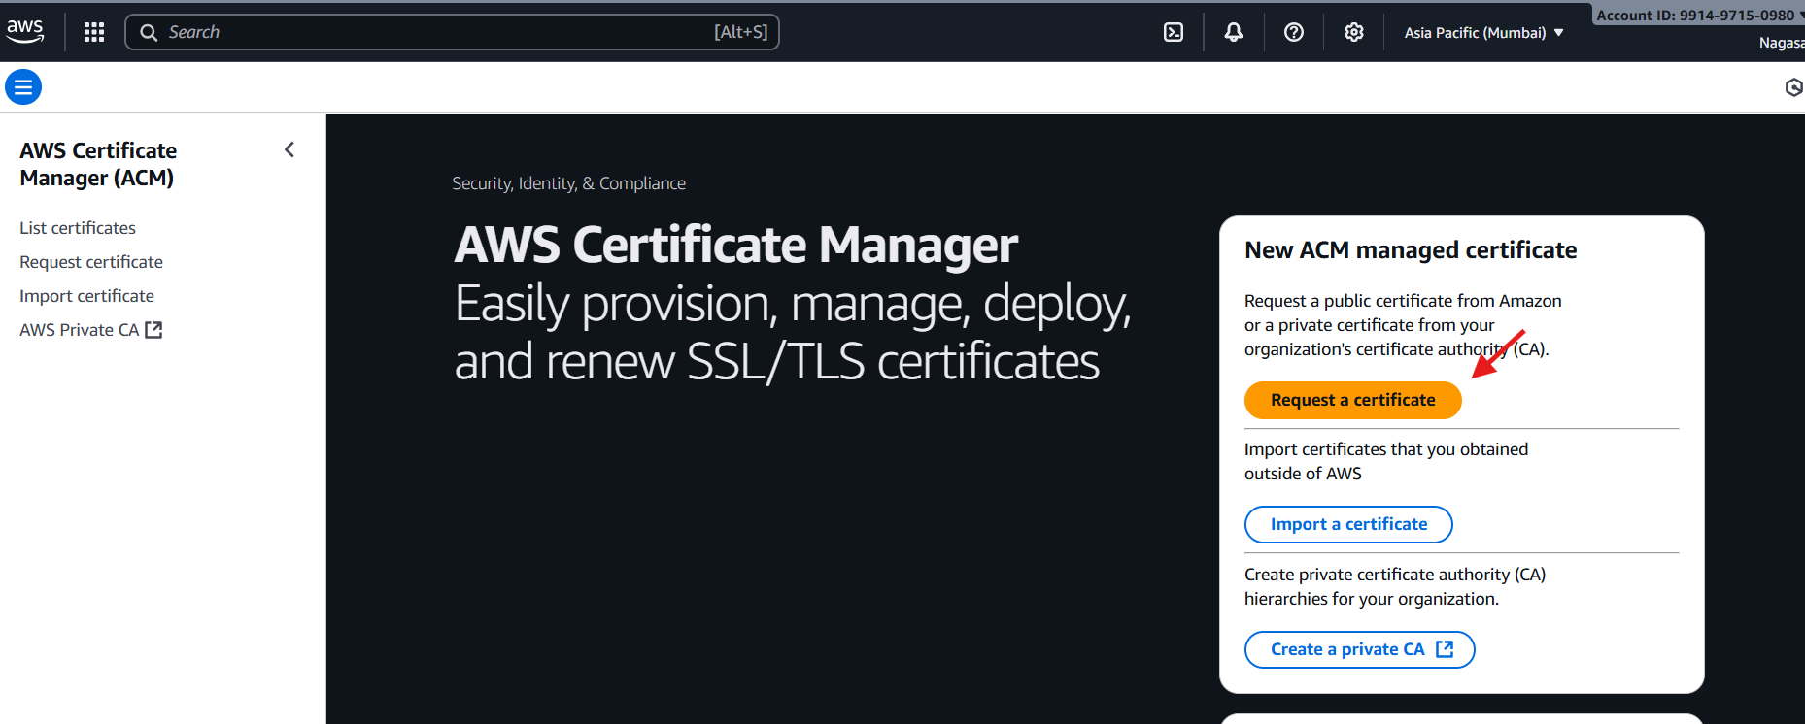
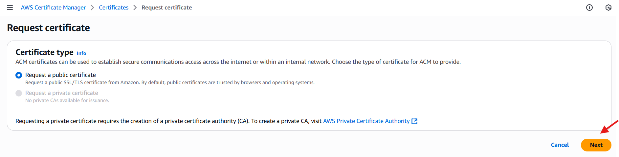
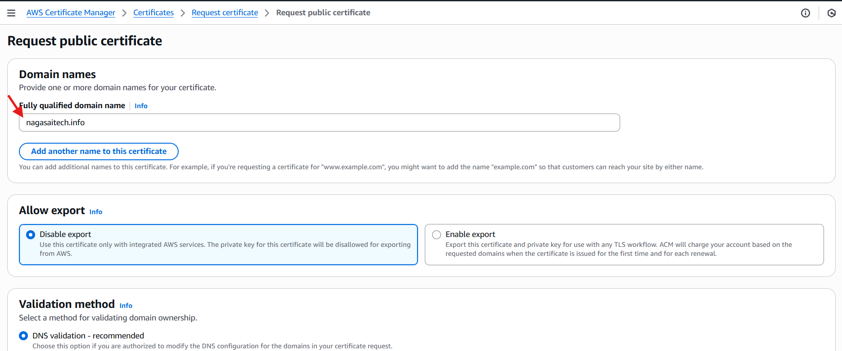
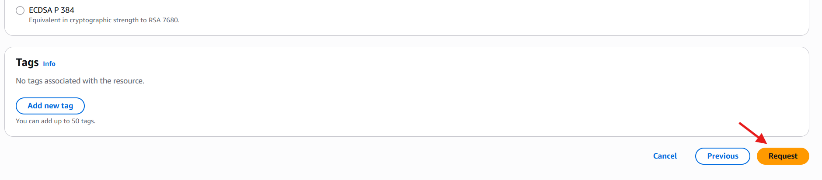
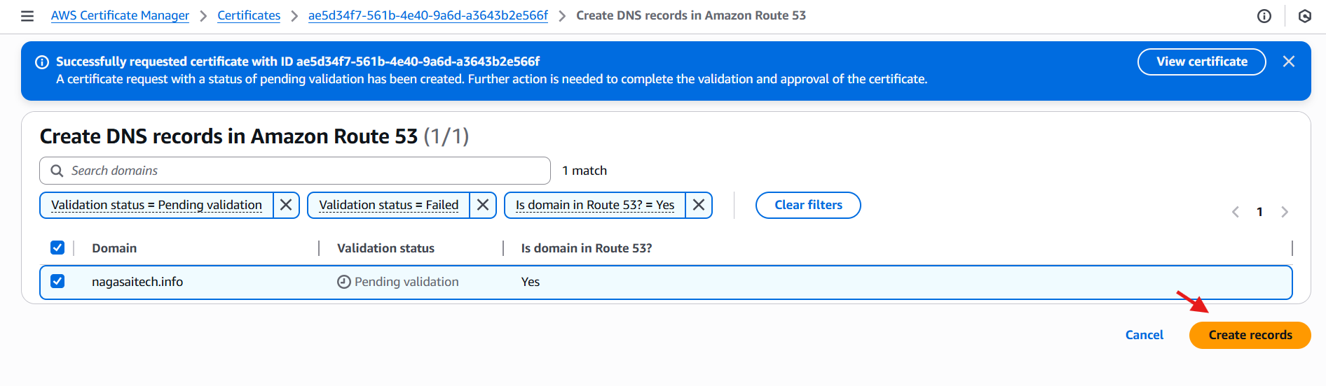
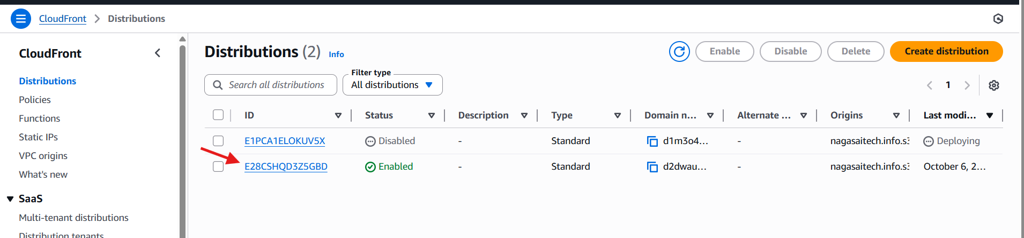
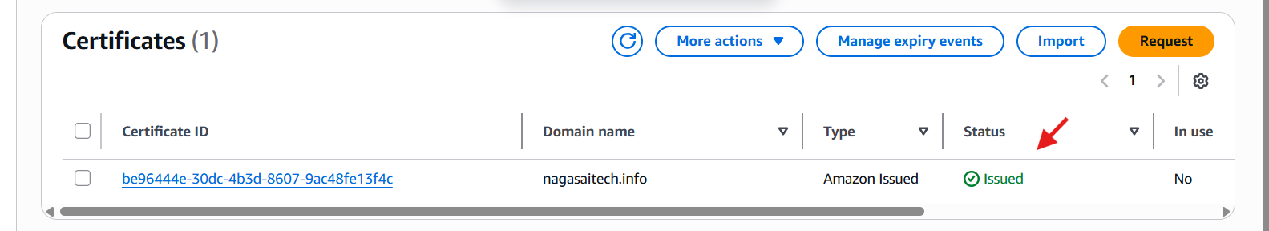
5.Create a Route 53 hosted zone and map the domain with the CDN.
Go to root 53 in aws console
Click on create records
The four websites will be generated go to go daddy.com
Your domain – name servers -copy the four dns names and add it in the server names

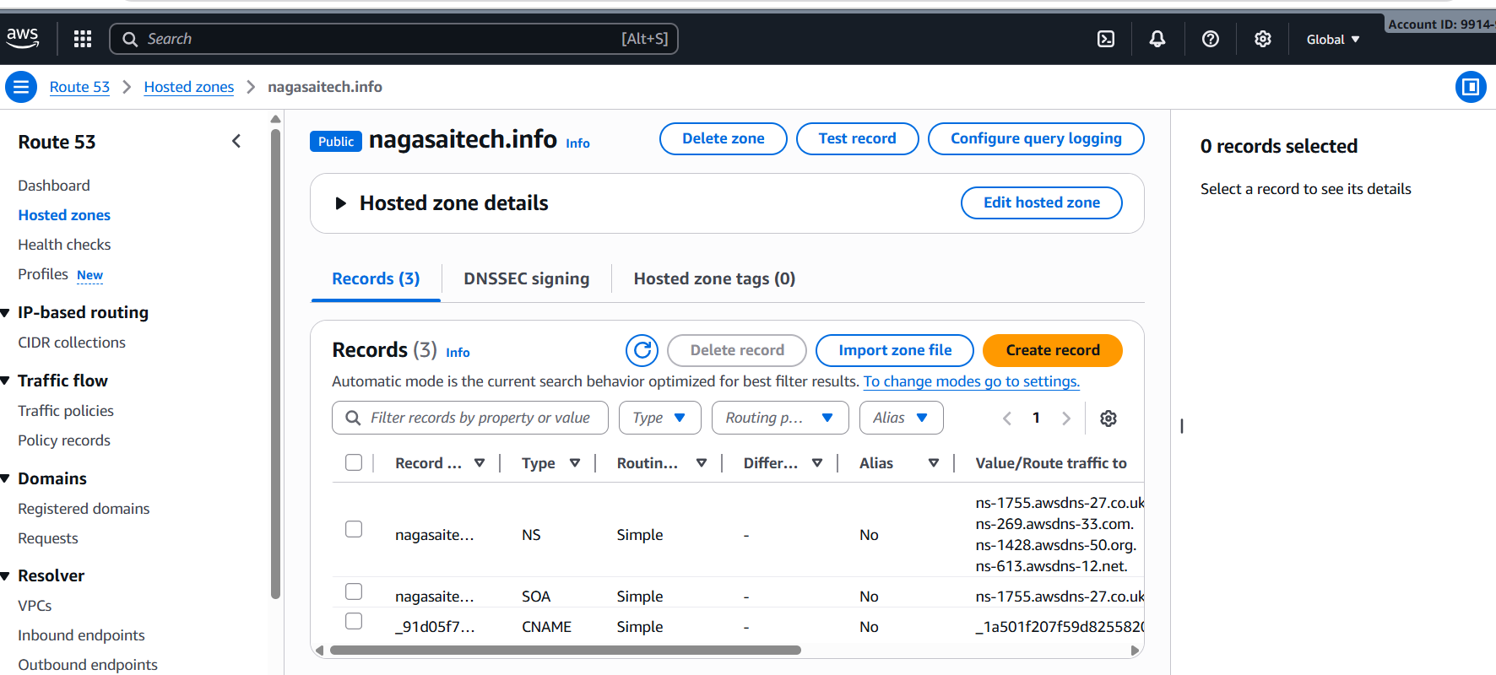
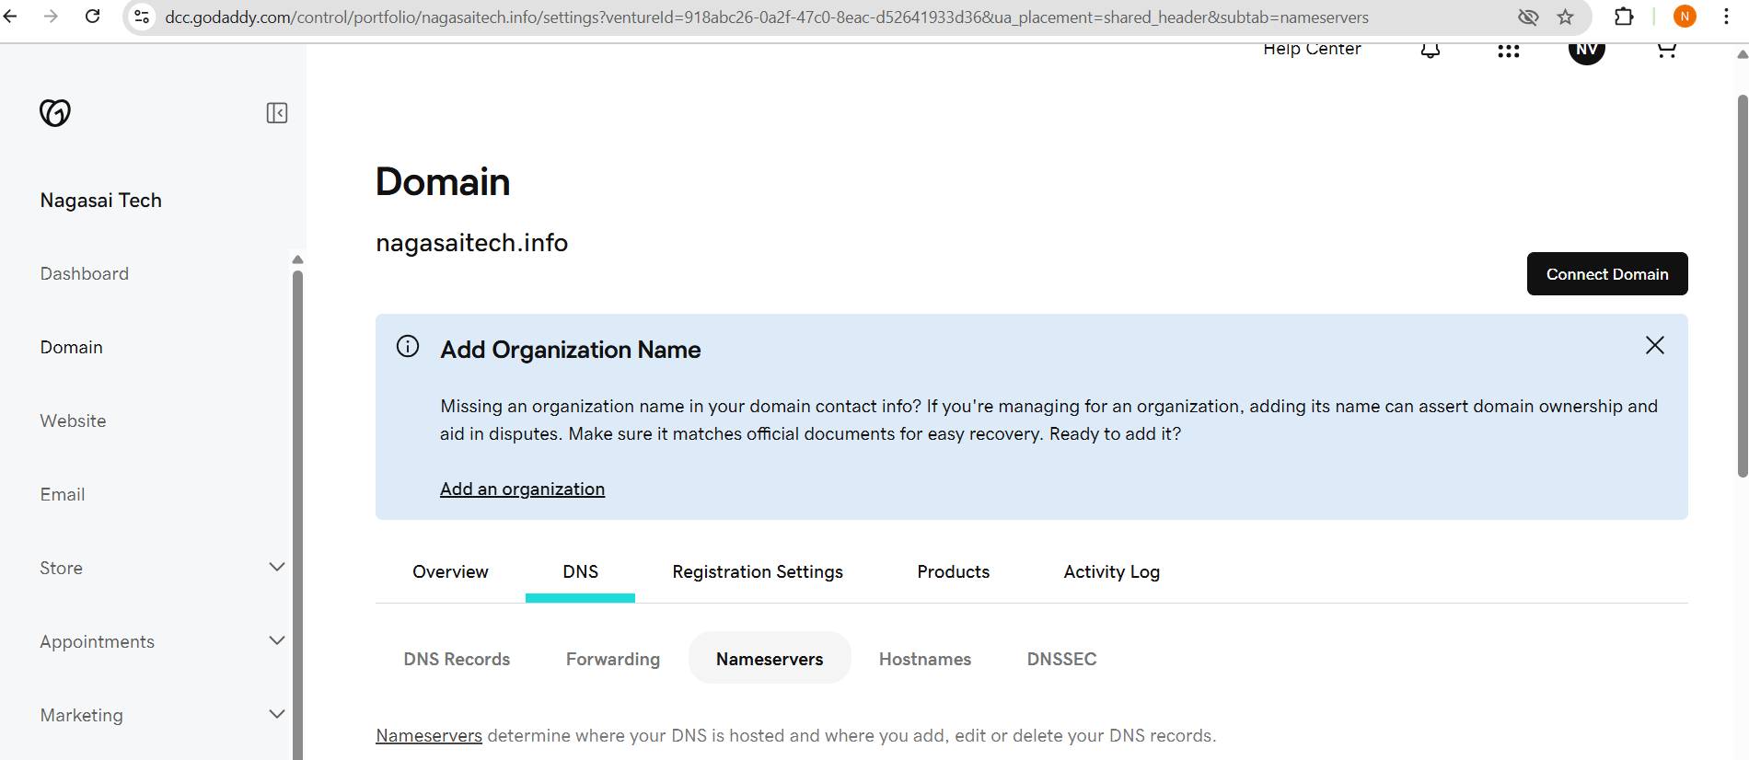
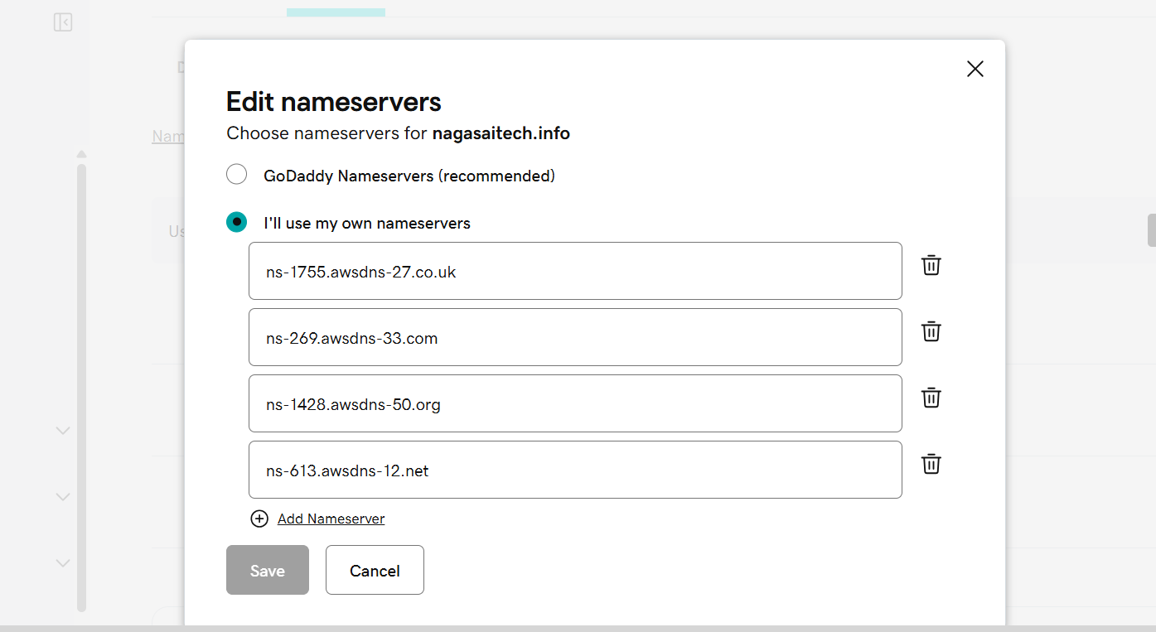
6.Update the index.html in the S3 bucket and ensure the updated file is accessible using the domain name.
Go to the cloud front distribution.
And copy the distribution domain name.
And paste it in the browser
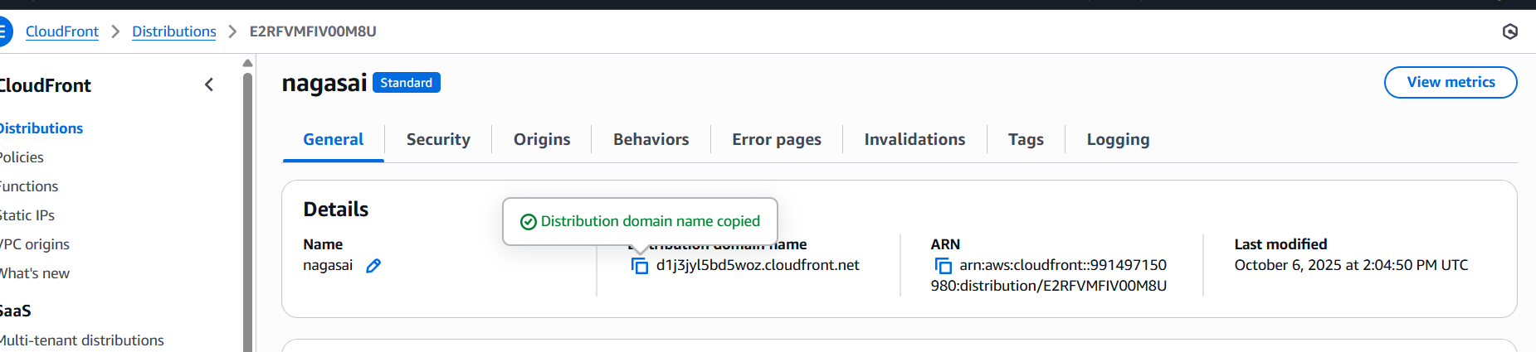
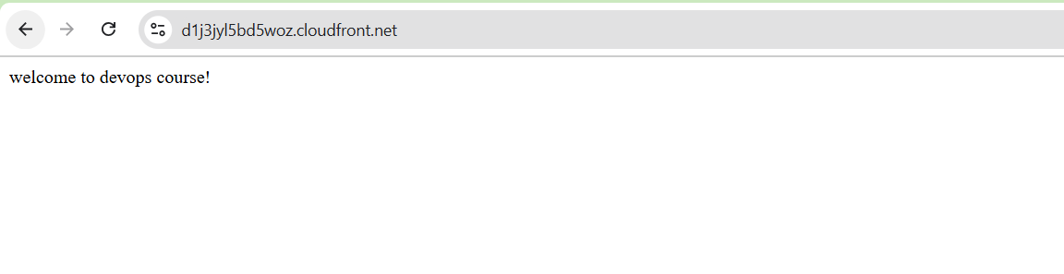
7.Share the domain name in Slack to test the connectivity.
